**DBT Assignment**

-Sanket Bhandarkar

PES2UG22CS506

Relational Schema-

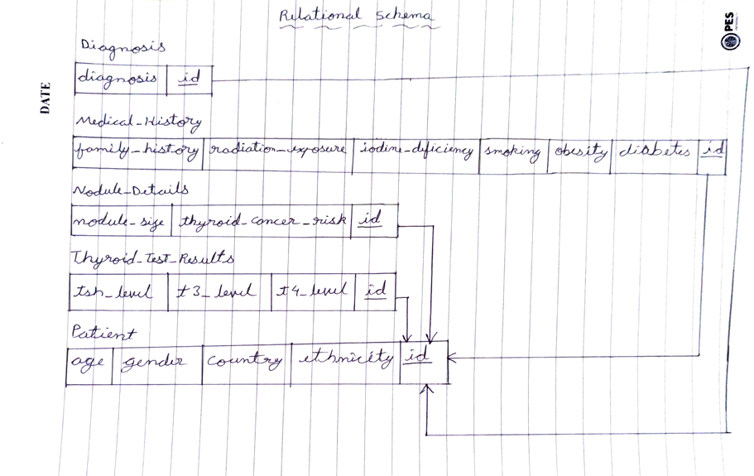

Select Queries-

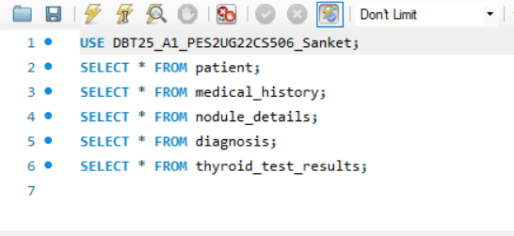

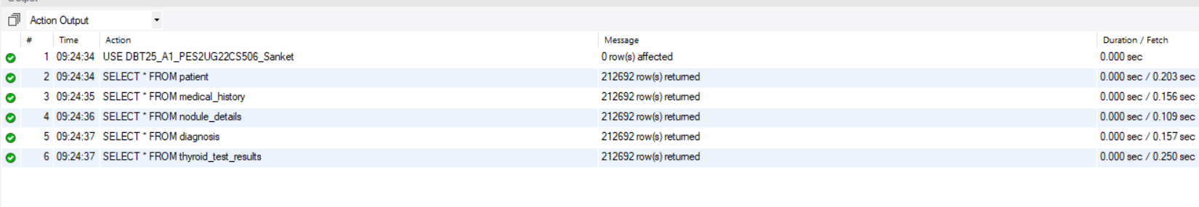

(SRN and name is inserted in the first record here )

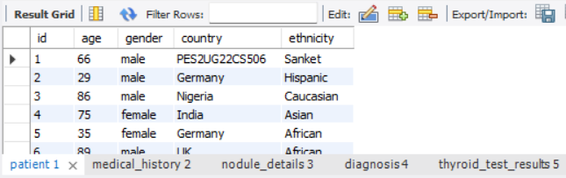

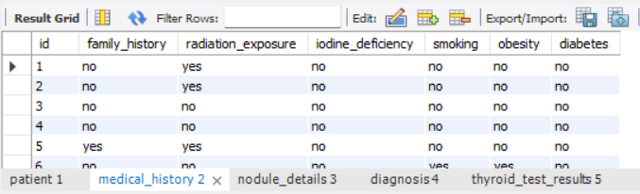

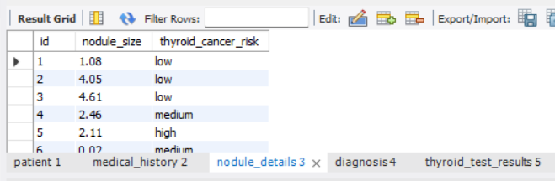

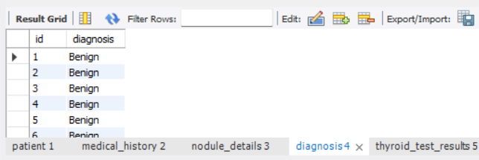

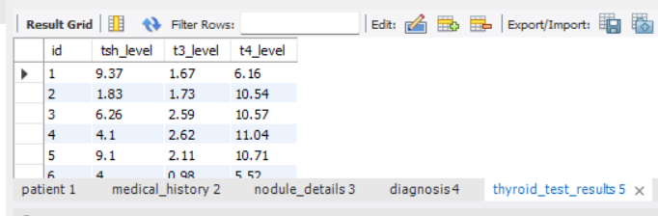

Row Count-

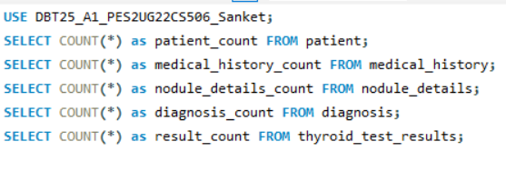

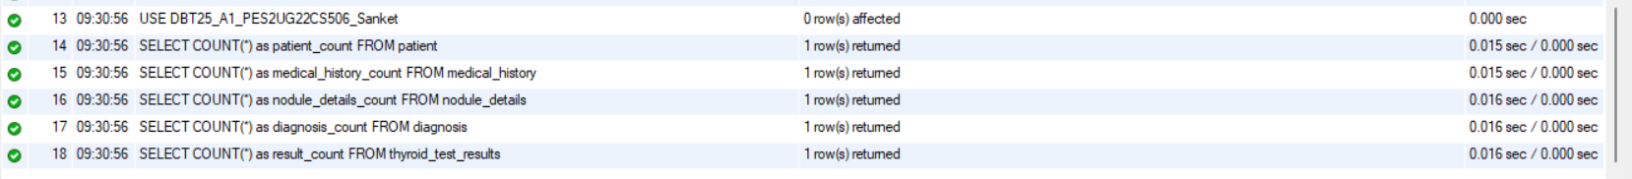

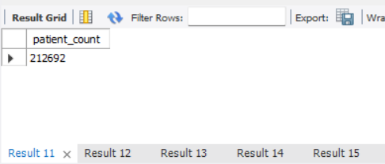

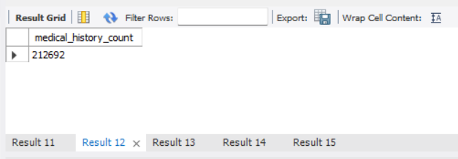

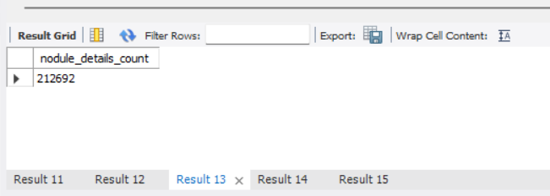

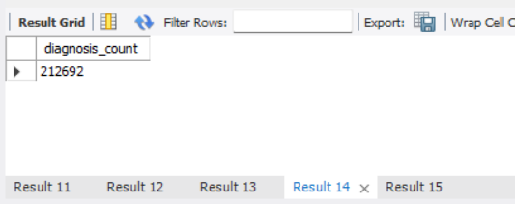

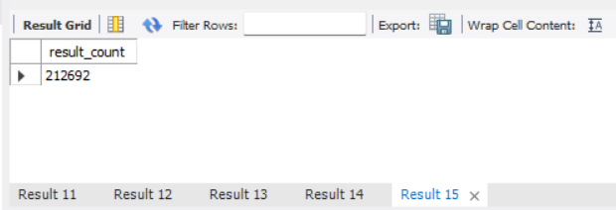

Select Queries Performance Analysis Before Index Creation-

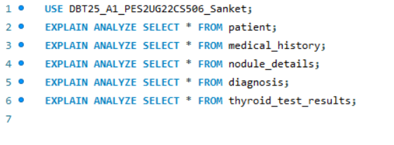

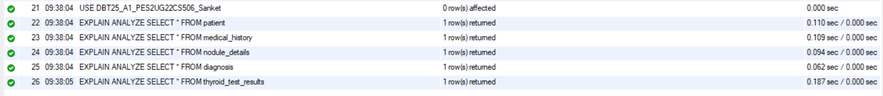

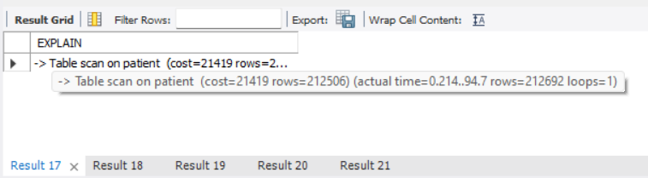

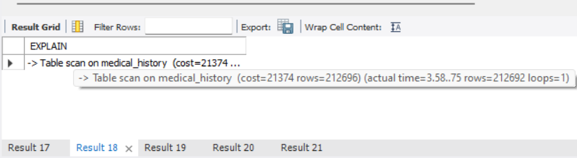

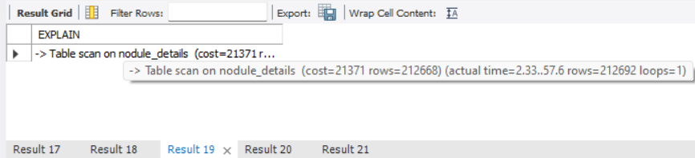

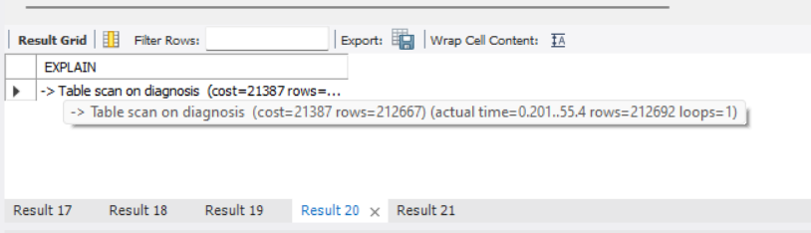

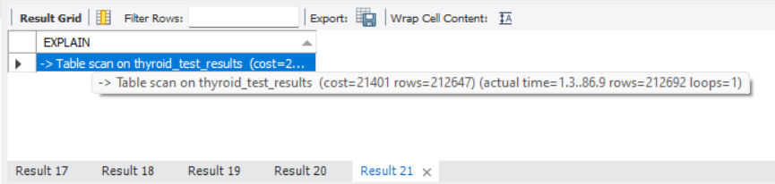

Select Queries Performance Analysis After Index Creation-

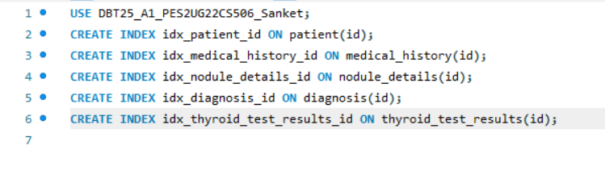

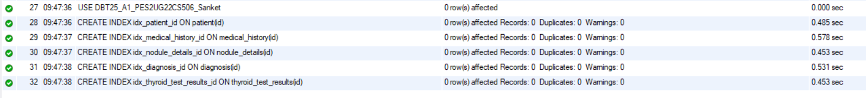

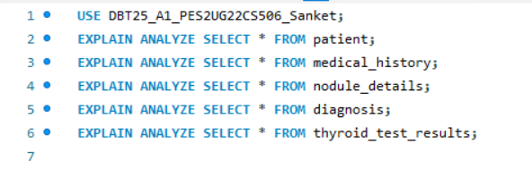

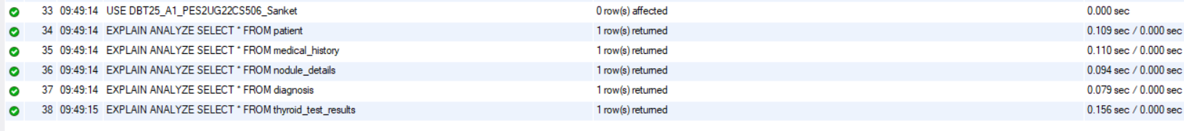

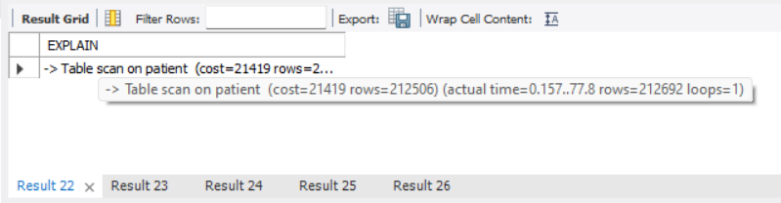

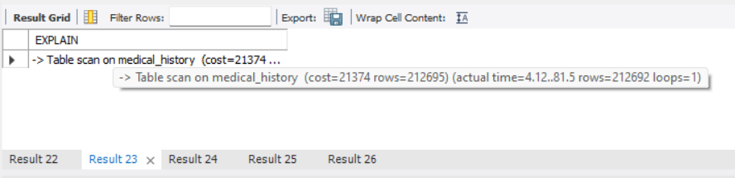

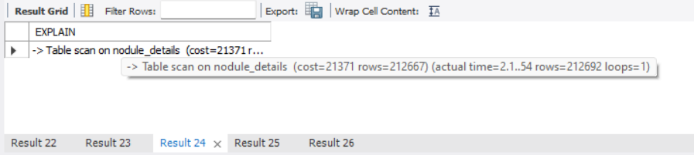

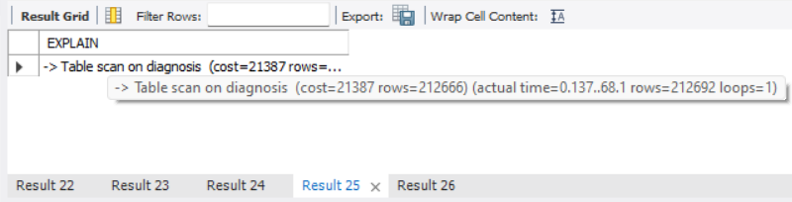

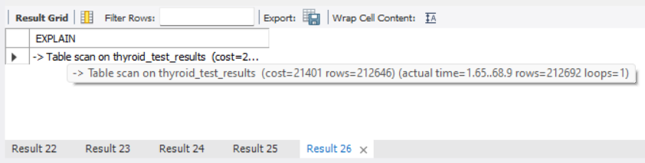

**Observation** -> No significant performance improvement due to lack of where clause , order by clause or join clause to leverage the indexed columns hence a regular table scan just like the case without indexing .

Count and Group by Query Before Index Creation-(table scan)

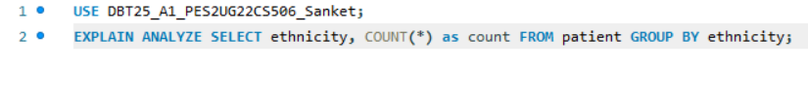



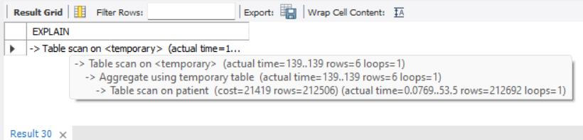

Count and Group by Query After Index Creation-(index scan)

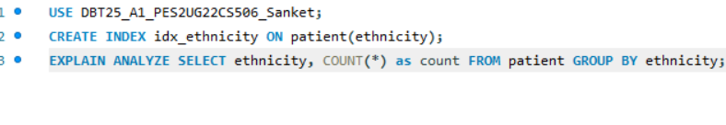



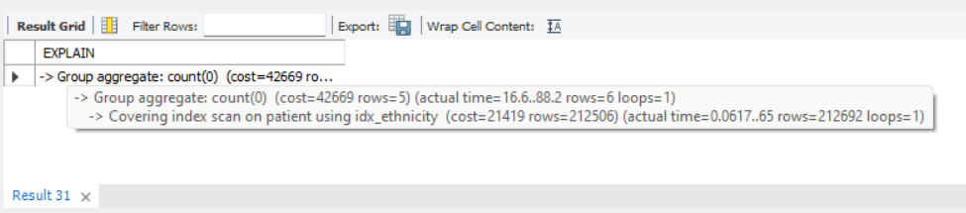

**Observation**-> Unlike the last comparison we see an actual significant cost reduction after the index creation which is due to the fact that we have used a group by statement to leverage the attribute/column on which index is created.

Join Query With Aggregation-

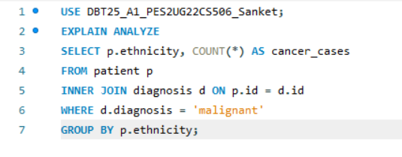



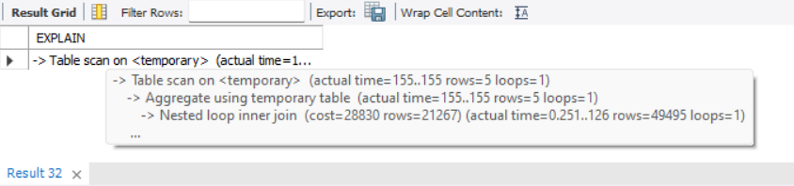

(Parse Tree)

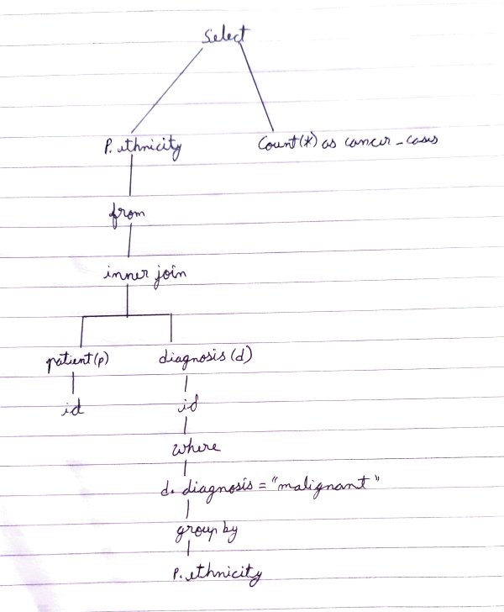

(Relational Algebra Query)

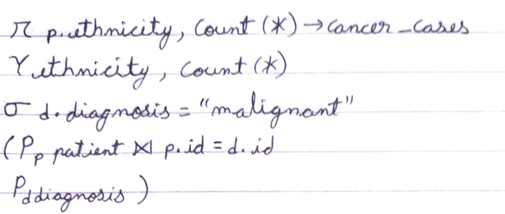

(Query Tree)

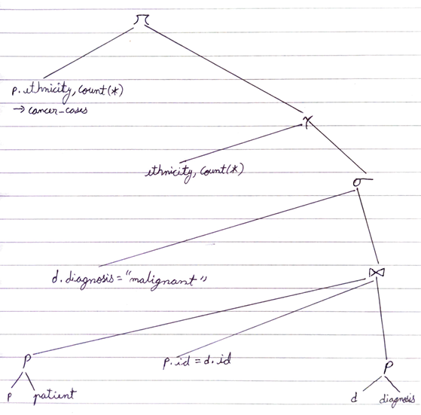

Join Query With Aggregation and Optimization (join order changed)-

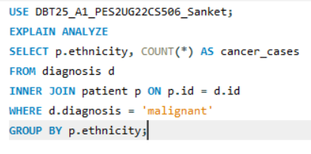



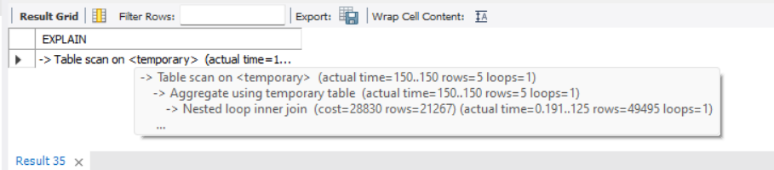

(Optimized Query Tree)

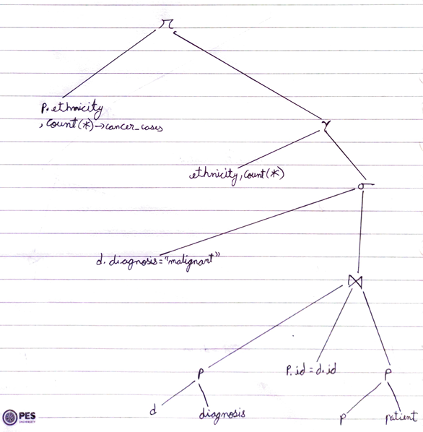

**Observation->** Very minimal performance improvement which is not too noticeable in this case as we are filtering with where clause before joining in this optimization.

3 Table Join Query-

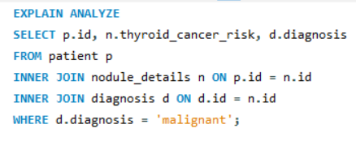



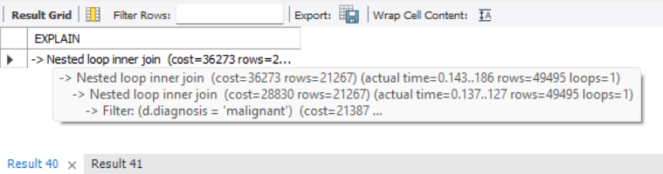

(Parse Tree)

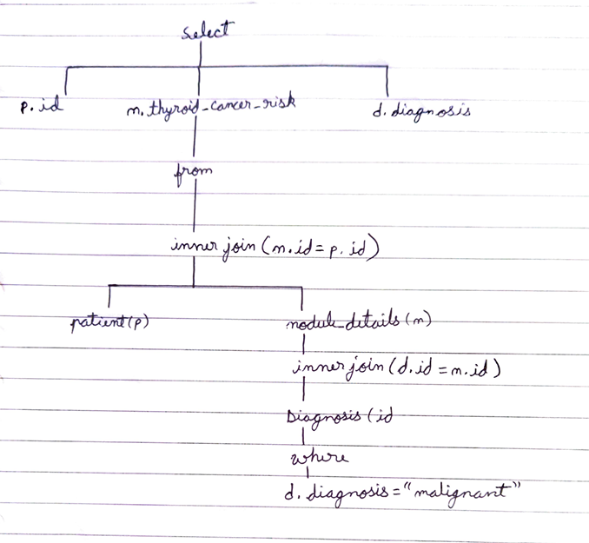

(Relational Algebra Query and Query Tree)

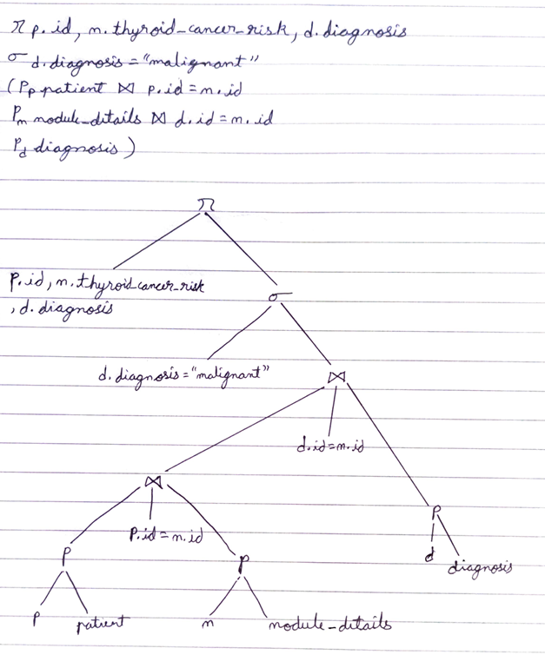

3 Table Join Query Optimization (Join order changed)-

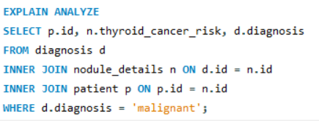



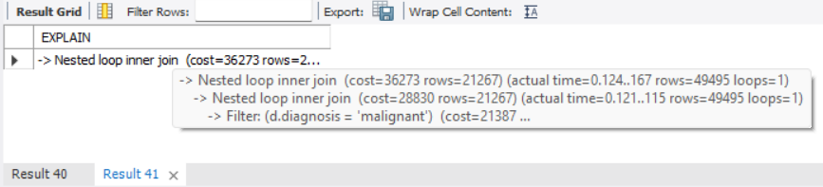

(Optimized Query Tree)

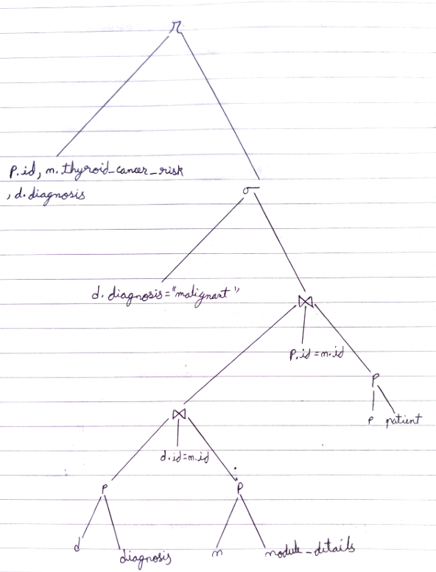

**Observation**-> The cost remains the same but there is minor performance improvements in terms of time taken which would be more

3 Table Join Query With Optimization (Index Creation)

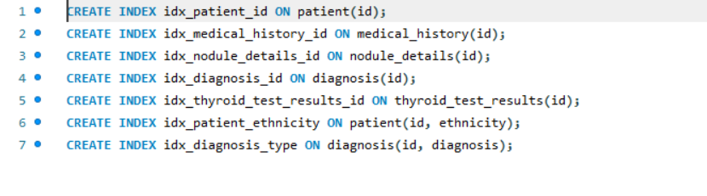

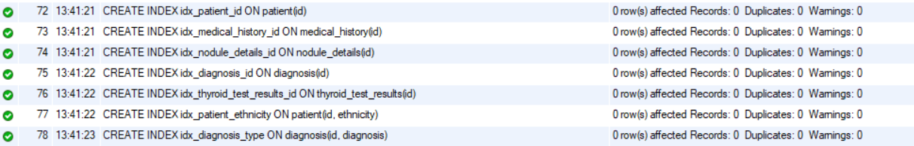

(Unoptimized Join Order)

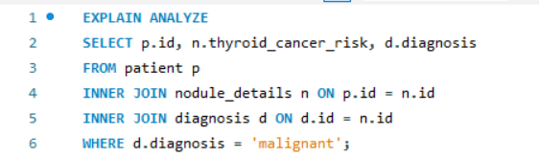



(Optimized Join Order)